Project Design Phase
Solution Architecture

Date | 05 July 2026
Project Name | Cab booking
Maximum Marks | 4 Marks

Solution Architecture:
The Ucab system is built using the MERN Stack to provide a secure and user-friendly cab booking platform.
Solution Architecture Diagram:

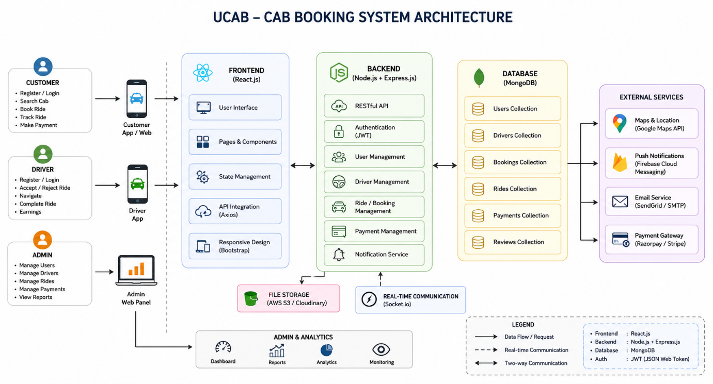
Components
Frontend (React.js)
- User Interface
- Booking Forms
- Dashboards
- Ride Tracking
Backend (Node.js & Express.js)
- REST APIs
- Authentication
- Booking Management
- Payment Processing
Database (MongoDB)
- Users
- Drivers
- Bookings
- Payments
Technologies Used
- React.js
- Node.js
- Express.js
- MongoDB
- JWT Authentication
- Axios
- Bootstrap
Expected Outcome
- Secure user authentication
- Easy cab booking
- Live ride tracking
- Online payment
- Booking history
- Admin dashboard

